Hacker earth digit sum: A.Digit Sum | Practice Problems
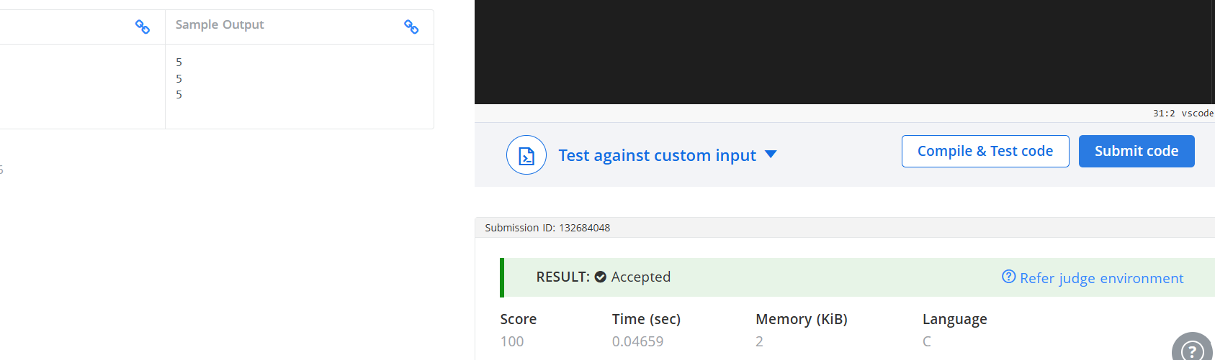
#include <stdio.h>

void solve() {
int n;
scanf("%d", &n);

// Get the last digit
int last_digit = n % 10;

// Get the first digit by dividing by 10 until a single digit remains
int first_digit = n;
while (first_digit >= 10) {
first_digit /= 10;
}

// Calculate and print the sum
int sum = first_digit + last_digit;
printf("%d\n", sum);
}

int main() {
int t;
// Read the number of test cases
if (scanf("%d", &t) == 1) {
while (t--) {
solve();
}
}

return 0;
}

